Two Faces of Mystery: Detective Fiction and Horror Fiction
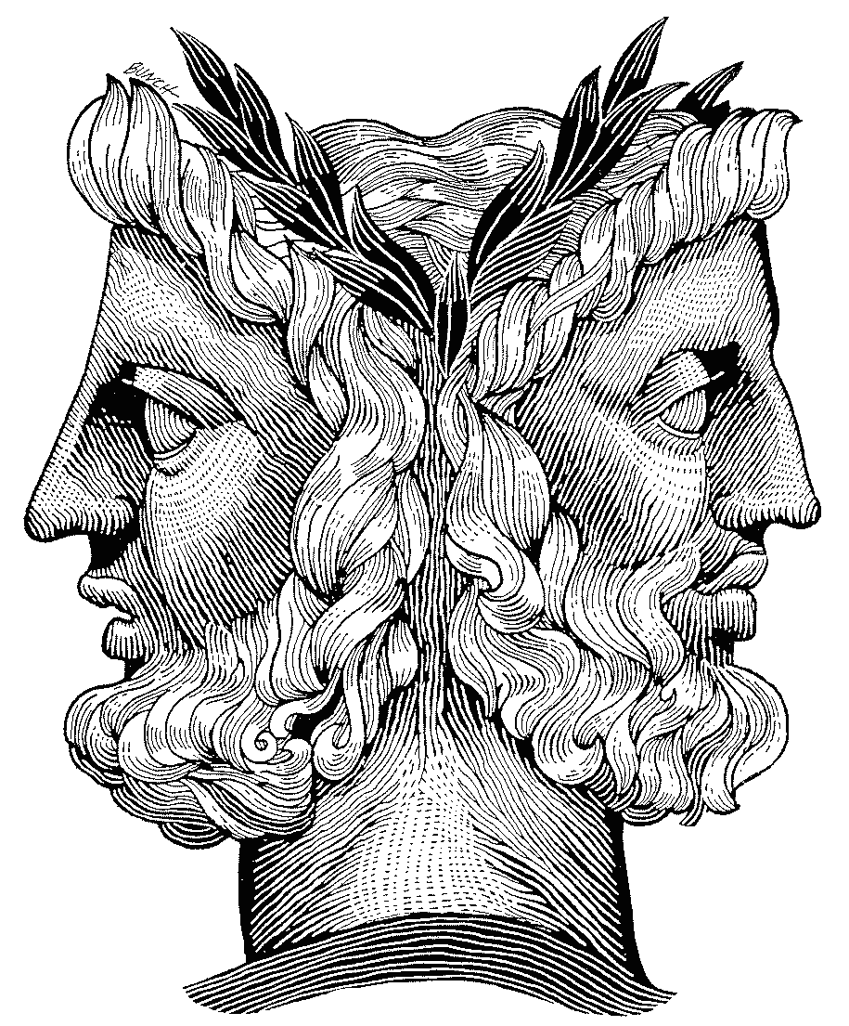

Freshman Seminar: One Credit
ARTSCI 1138.xx
Day TBA
Time and Place TBA

Professor Steven Fink
Department of English
Office Hours TBA
114 University Hall

Course Description: Edgar Allan Poe was a master of both the horror story and the detective story, and in some respects these are antithetical genres: one indulges in fantasies of the supernatural and irrational, while the other imagines a world that can be comprehended and restored to order by the super-rational detective hero. But both genres construct plots that start with a mystery—some incident or perception that seems to defy the laws of reason or of nature—a murder, a monstrous apparition, a ghost, etc. While the horror story irresistibly pulls the characters—and the readers—into an imagined world where the irrational or supernatural must be accepted as “real,” the detective story imagines a world in which the super-rational triumphs over the irrational. In this course we will read and analyze examples of these complementary genres—first with some examples of each genre by Poe, and then in Arthur Conan Doyle’s Sherlock Holmes novella The Hound of the Baskervilles and Bram Stoker’s classic novel of horror, Dracula. Time permitting, we will throw in some stories by H.P. Lovecraft, Agatha Christie, and Henry James’s classic “The Turn of the Screw.”

Fundamentally, we will approach these works in the context of understanding literary formulas, genres, and archetypes, in terms of both artistic form and the cultural context and implications of these genres . Our critical framework will draw upon some relevant selections from John C. Cawelti’s study Adventure, Mystery, and Romance: : Formula Stories as Art and Popular Culture, and from Terry Heller’s The Delights of Terror: An Aesthetics of the Tale of Terror.

Texts: You will be asked to purchase the following texts, both of which are widely available in new and used editions in bookstores and online. Any edition of the complete texts is sufficient:
Sir Arthur Conan Doyle, The Hound of the Baskervilles
Bram Stoker, Dracula
All readings from Edgar Allan Poe can be found online at the excellent Edgar Allan Poe Society of Baltimore website, http://www.eapoe.org.
Selected readings from John G. Cawelti, Adventure, Mystery, and Romance and from Terry Heller, The Delights of Terror will be posted on Carmen.
Sources for additional materials will be provided in class.

Course requirements: You are expected to attend each class, having read all the materials assigned for that day, and participate in class discussions. I expect active engagement. This means taking notes on your readings and writing down questions or reactions to bring to class—a good practice is to prepare for each class by writing down at least three questions you would like to have addressed in class discussion. I will evaluate your participation by how actively you provide comments and ask questions.

Each week you will be required to keep a critical journal, writing at least a page of 250 words. In this journal you will be expected to reflect on the reading of the week and/or past class discussions. Your journal entries may be submitted in hard copy or electronically, and you should retain and compile them for the end of the course. For your final journal entry, you will identify and reflect upon some work (in any medium--short story, novel, graphic novel, film, TV show, etc.) that you have encountered outside of class to which our class material and discussions seem to be relevant and illuminating. While the journal entries are exploratory and relatively informal, I nevertheless expect clear, precise, and correct writing that demonstrates astute critical thinking about the issues of the seminar.

Grading: Satisfactory/ Unsatisfactory
Class participation: 35%
Critical Journals: 65%

Course Objectives:
- To get a better understanding of narrative and plot structure, literary formulas, genres, and archetypes, in terms of both artistic form and the cultural context and implications of these genres
- To gain insight into the specific popular culture genres of horror fiction and detective fiction, both in aesthetic and historical terms
- To enhance critical thinking, writing, and speaking skills

Academic Misconduct
Academic misconduct is a violation of the code of Student Conduct. The University defines academic misconduct as any activity that compromises the academic integrity of the institution, or subverts the educational process. Some examples are copying other people’s work, having others write a paper for you, or cheating on examinations. For more information please go to http://www.osu.edu/offices/oaa/procedures/index.htm.

Students with Disabilities

Students with disabilities that have been certified by the Office for Disability Services will be appropriately accommodated and should inform the instructor as soon as possible of their needs. The Office for Disability Services is located in 150 Pomerene Hall, 1760 Neil Avenue; telephone 292-3307, TDD 292-0901; http://www.ods.ohio-state.edu/

Biographical Statement
I have been on the faculty of the OSU Department of English since 1982, specializing in 19th- and 20th-century American literature. For the past five years, I have been the Associate Executive Dean of the College of Arts and Sciences, overseeing all curriculum matters in the college. I am the author of a book on Henry David Thoreau and numerous chapters and articles on American literature. I have twice been selected as the OSU English Departent’s Undergraduate Professor of the Year; and I was the 2008 recipient of OSU’s Rodica C. Botoman Award for Undergraduate Teaching in the Humanities.

Weekly Readings:

1. Introduction: Plot, Formulaic Literature, horror and detective fiction
Cawelti, Chapter 1 “The Study of Literary Formulas”
Heller, Chapter 1, “Introduction”

2. Edgar Allan Poe, “The Sphinx”
Cawelti, from Ch. 2, “Notes Toward a Typology of Literary Formulas”: “Mystery”

3. Poe, “The Fall of the House of Usher”
Heller, ch. 8, “The Entrapped Critic: Poe’s ‘The Fall of the House of Usher”

4. Poe, “Murders in the Rue Morgue”
Cawelti, Ch. 4, “The Formula of the Classic Detective Story”

5. Poe, “Premature Burial”

6. Poe, “Ligeia”
Heller, Chapter 7, “Anticlosure: Poe’s ‘Ligeia’”

7. Arthur Conan Doyle The Hound of the Baskervilles
Cawelti, chapter 5, “The Art of the Classical Detective Story”

8. Conan Doyle, The Hound of the Baskervilles, continued.

9. Conan Doyle, Hound of the Baskervilles, continued;
Another Sherlock Holmes short story, TBD

10. Bram Stoker, Dracula.
Heller, chapter 5, “”The Aesthetics of the Horror Thriller: Stoker’s Dracula”

11. Stoker, Dracula, continued.

12. Stoker, Dracula, continued.
Proulx “Brokeman Mountain”

13. Stoker, Dracula, continued.

14. Henry James, The Turn of the Screw

15. James, The Turn of the Screw, continued.

16. brief presentation of final journal entry on outside material

